***Experiment no. 01***

***Experiment name:***

Linux mint 18.2 installation steps in Laptop as dual boot.

***Aim and objective:***

* **It’s very secure**
* **Open source**
* **Compatible with lower-end hardware**
* **We can run it alongside our current operating system**
* **It’s free**
* **It’s easy to set up.**
* **Easy updates**
* **Everything we need is included**

***Experiment setup:***

I installed linux mint 18.2 alongside my windows 10.Here is how it was done:

* *Linux alongside Windows:*

I used the method is called dual booting Linux with Windows. Here, we will install Linux on a system that already has Windows. And when our system powers up, we can choose if we want to use Windows or Linux. This involves touching the disk partition and sometimes boot order. Absolute beginners often find it complicated but this is the best way to use Linux and Windows together in one system. And in this article, we’ll see how to dual boot Linux Mint with Windows 10.

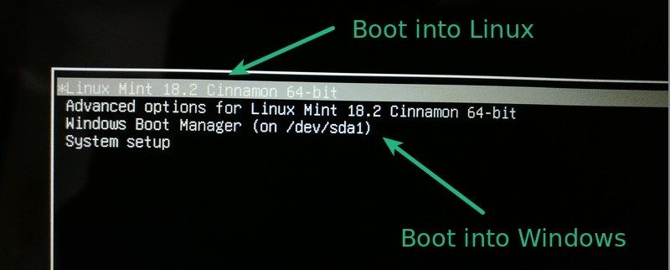

***Step 1: Burnig the USB***

I went to Linux Mint website and download ISO file. This ISO file is the disk image that we can burn to a USB or DVD.

Once you have downloaded the Linux Mint ISO, you need a tool to write the image to a disk. I used a free tool called Universal USB Installer in Windows:

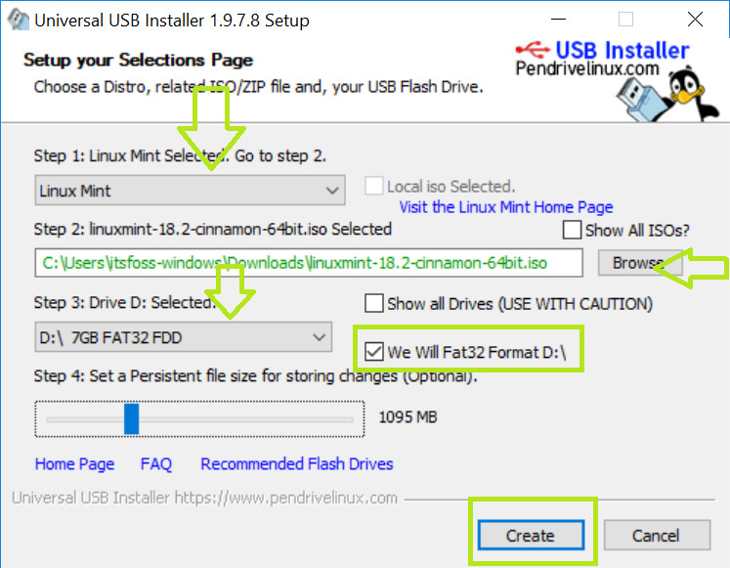.

***Step 2: Disk partition for linux***

In Windows 10, I went to start menu and typed ‘partition’. This will bring up Disk Management utility.  Then I selected the disk in which I would make some free space by shrinking the volume:

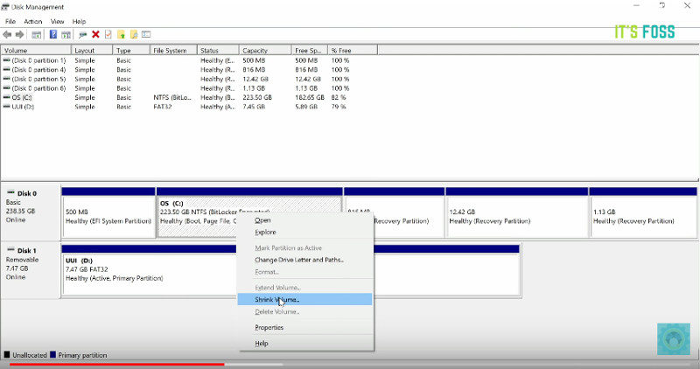

***Step 3: Boot in to live USB***

Pluged in the live USB into the computer and restarted the computer. While booting the computer I  **pressed F9** function key to go to the boot menu. Then,I chosed the option to boot from **USB**or **Removable Media**.

***Step 4: Start the installation***

It took some time to boot from the live USB.Once it booted in to live disk, we had been provided to Try Linux Mint or Install Linux Mint. Even if we had chosed to try it, we can find the install option on the desktop:

[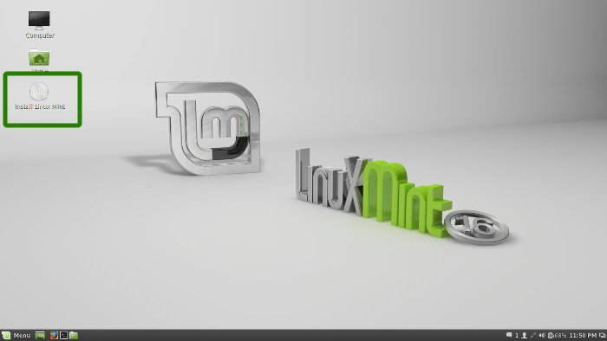](https://itsfoss.com/wp-content/uploads/2013/12/Linux-Mint-Installation-1.jpeg)

In next few screens, we had been asked to choose the language of the operating system. It then did some checks on available space, battery and Internet connection.

[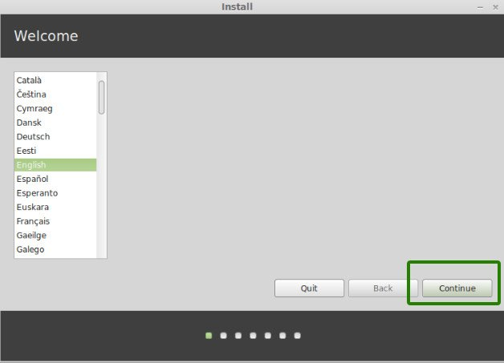](https://itsfoss.com/wp-content/uploads/2013/12/Linux-Mint-Installation-2.jpeg)

[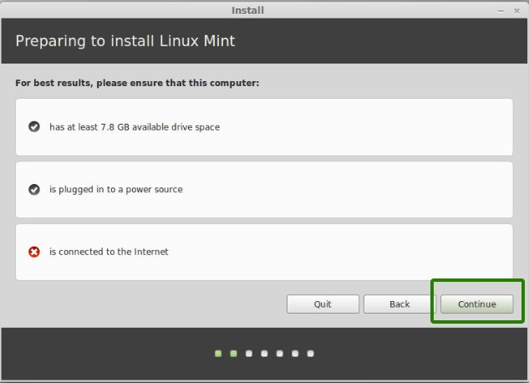](https://itsfoss.com/wp-content/uploads/2013/12/Linux-Mint-Installation-3.jpeg)

***Step 5: Prepare the partition***

This is the most important part of the whole installation. Where to install Linux Mint? As mentioned before, I prefer separate partitions for Windows and Linux. Windows is already installed here, we’ll prepare a new partition for Linux Mint. In the Installation Type window, choose **Something Else**:

[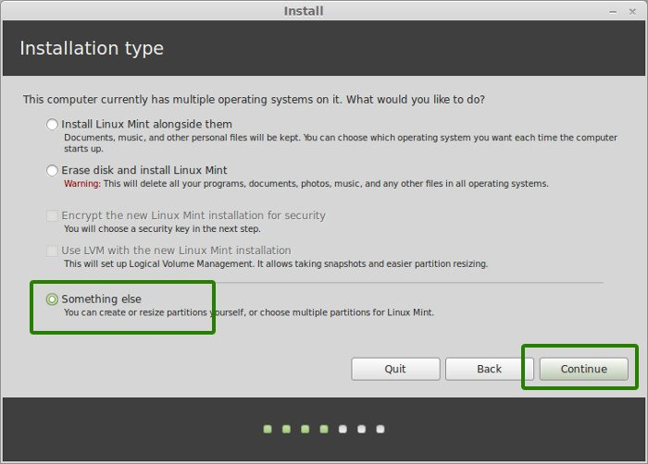](https://itsfoss.com/wp-content/uploads/2013/12/Linux-Mint-Installation-4.jpeg)

***Step 6: Create root, swap and home***

Since we already created a new partition in Windows, it’s time to install Linux Mint on it. Now, there are several ways to do it. But here,I did it in the following way.  
Created a root partition first. Choosed the free space available and click on +.

[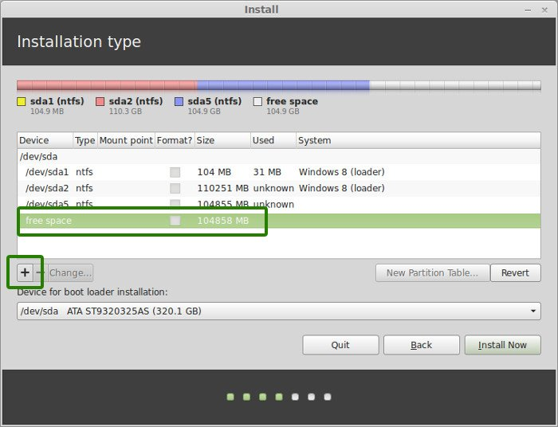](https://itsfoss.com/wp-content/uploads/2013/12/Linux-Mint-Installation-6.jpeg)

Here, choose the size of the root (10 GB is enough but I chose to have 20 here), choose **ext4** file system, and mount point as **/** (i.e. root):

[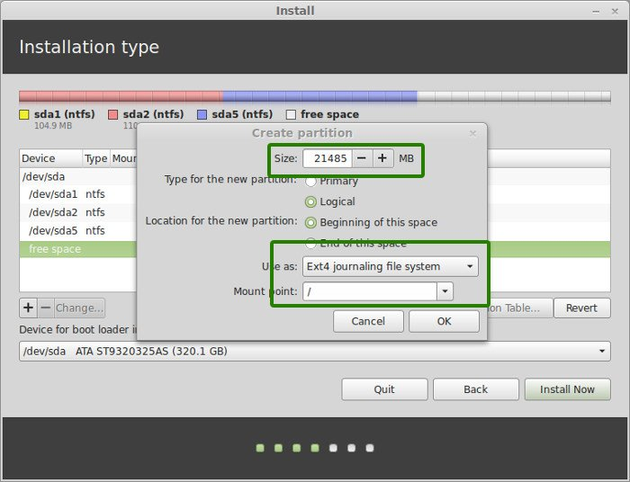](https://itsfoss.com/wp-content/uploads/2013/12/Linux-Mint-Installation-7.jpeg)

Now, next is to create the swap partition. It is advised by many that [Swap](http://www.centos.org/docs/5/html/5.1/Deployment_Guide/s1-swap-what-is.html) should be double of your RAM. You can choose the swap size accordingly.

[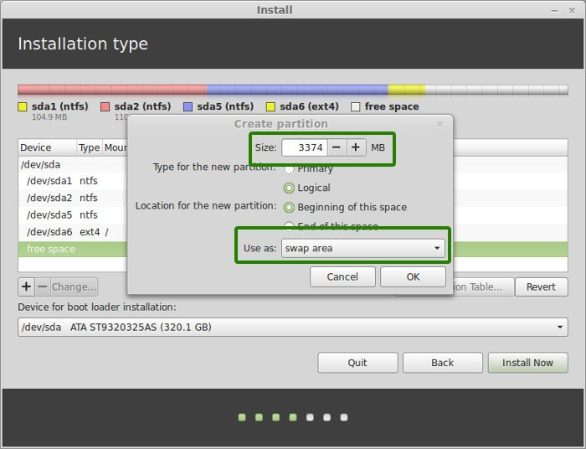](https://itsfoss.com/wp-content/uploads/2013/12/Linux-Mint-Installation-8.jpeg)

The next step is to create Home. Try to allocate the maximum size to Home because this is where you’ll be downloading and keeping the files.

Once you have created Root, Swap and Home partitions, click on Install Now button.

[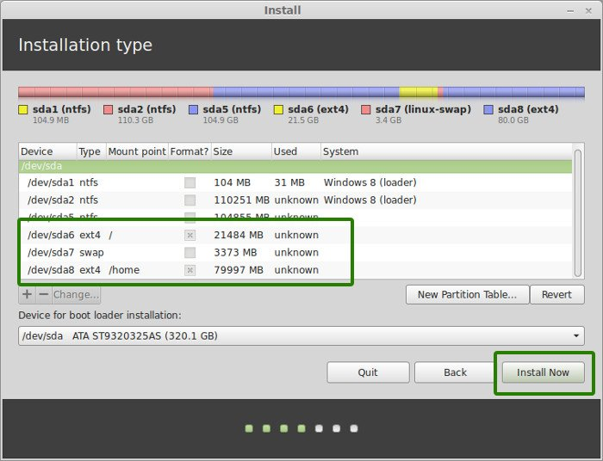](https://itsfoss.com/wp-content/uploads/2013/12/Linux-Mint-Installation-10.jpeg)

***Step 7: Follow the trivial instructions***

Then I customized the following things according to my necessity.

[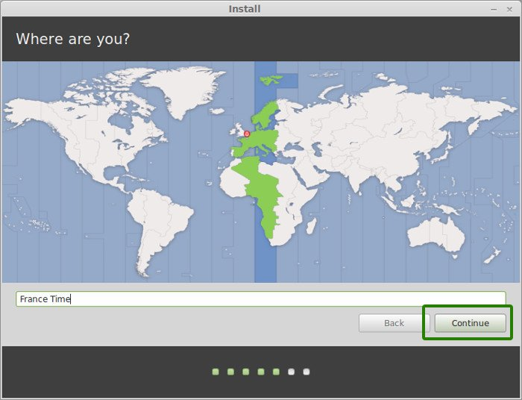](https://itsfoss.com/wp-content/uploads/2013/12/Linux-Mint-Installation-11.jpeg)[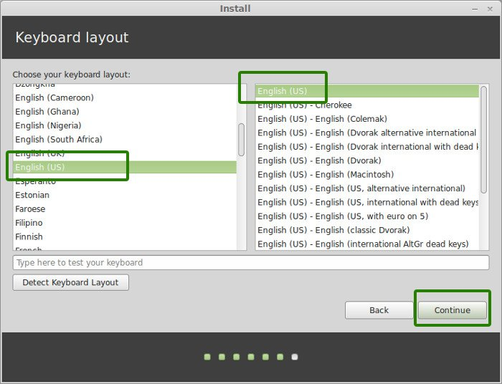](https://itsfoss.com/wp-content/uploads/2013/12/Linux-Mint-Installation-12.jpeg)

After this window we will get a window to personalize and set up the username and password for the Operating System.

[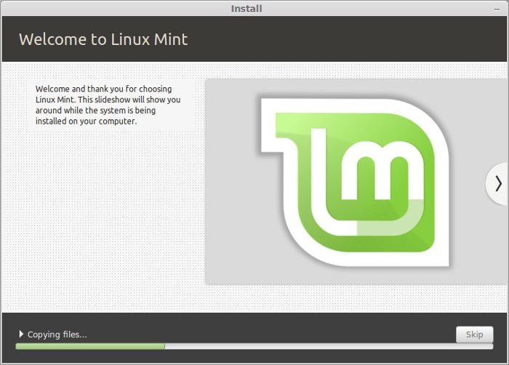](https://itsfoss.com/wp-content/uploads/2013/12/Linux-Mint-Installation-14.jpeg)

Once the installation is over, I was presented with the option to keep trying live version or to restart the system.

[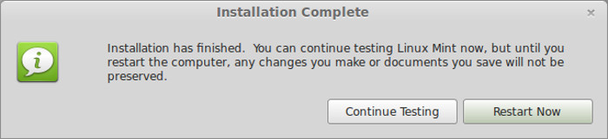](https://itsfoss.com/wp-content/uploads/2013/12/Linux-Mint-Installation-15.jpeg)

And that would be it. On next boot, you will see the option of Linux Mint on the grub screen.

***Conclusion:***

Since linux is free and open source Operating System,I usually prefer to use linux Operating System.It is even more stable and secured than the other operating systems. it doesn’t allow any kind of virus. For this, no risky think happened in Linux about virus.For more various other benefits I like to use Linux Operating System,I think obviously it’s a good choice.